Chapter 7 User Manual
This chapter is the operating manual for the system as delivered. It covers installation, then every real screen in the order a new user meets them, with what the user does and what the system shows. Every screenshot is of the current interface, captured from the running system on 2026-09-23; no screen is mocked up and no capability is illustrated that the system does not have. The chapter closes with an explicit list of what the manual must not promise.
What the system is. It drafts a chest X-ray report from five similar archived cases and hands it to a doctor to review, edit and sign. Every report carries the line: “Drafted from 5 archive cases, then reviewed and edited by the reporting radiologist. Not an autonomous diagnosis.” You remain the author.
Who can use it. There is one role: the doctor. There is no administrator account, no administrator screen and no role column in the database. A doctor may read any report but may write only their own; every write against another doctor’s report is refused.

7.1 Installation and Setup

7.1.1 Prerequisites
Table 7.1: What must be present before the system will start.
Source: 01_facts/environment.md §7.
Requirement | Detail
A CUDA-capable GPU | Developed and measured on an NVIDIA RTX 4070 Ti SUPER (16,376 MiB). The full stack peaks at 7,125 MiB, so roughly 8 GiB of free VRAM is the practical minimum.
Python 3.12.3 | For the backend and the machine-learning pipeline.
Node.js 24.18.0 and npm 11.16.0 | For the frontend.
Ollama | Version 0.34.2 produced every evaluation number; 0.34.3 is installed today.
The clinical labeller checkpoint | chexbert.pth (1.31 GB) must be fetched separately and placed at the configured path. It is not in the repository and must never be added to it — Stanford Docket S20-295 forbids redistribution. Without it the system still starts; the contradiction check is dropped and recorded as not run.

7.1.2 Setup, in order
# 1. Python environment
python -m venv .venv && .venv/Scripts/activate
pip install -r requirements.txt # NOTE: unpinned; see Ch. 5 §5.1.4

# 2. Models
ollama pull llama3:8b # digest 365c0bd3c000
# BiomedCLIP downloads on first embedder construction.
# chexbert.pth must be fetched separately (see above).

# 3. Database
cd backend && alembic upgrade head # head = 7f2a91c4d6e8

# 4. Backend (loads BiomedCLIP, EasyOCR and CheXbert at startup)
.venv/Scripts/python.exe -m uvicorn app.main:app --port 8000

# 5. Frontend
cd frontend && npm install && npm run dev # serves on :3000
The frontend must be served from port 3000 unless the allowed-origin setting is changed to match. The backend’s allowlist holds exactly one origin. Served from any other port, every action fails with “Failed to load report”, which does not name the real cause.

7.1.3 Verifying the stack is healthy
Open http://localhost:3000. The service health strip performs real reachability checks against four components — the API, Ollama, the vector store and the GPU — rather than reporting a static value. A healthy system reports all four reachable, and the system statistics screen reports the index size read from the vector store itself, which should be 2,462.
Everything runs locally. The upload screen states it: “Everything runs locally; nothing leaves the building.” There is no external API call anywhere in the request path.

7.2 Landing, Registration and Sign-in
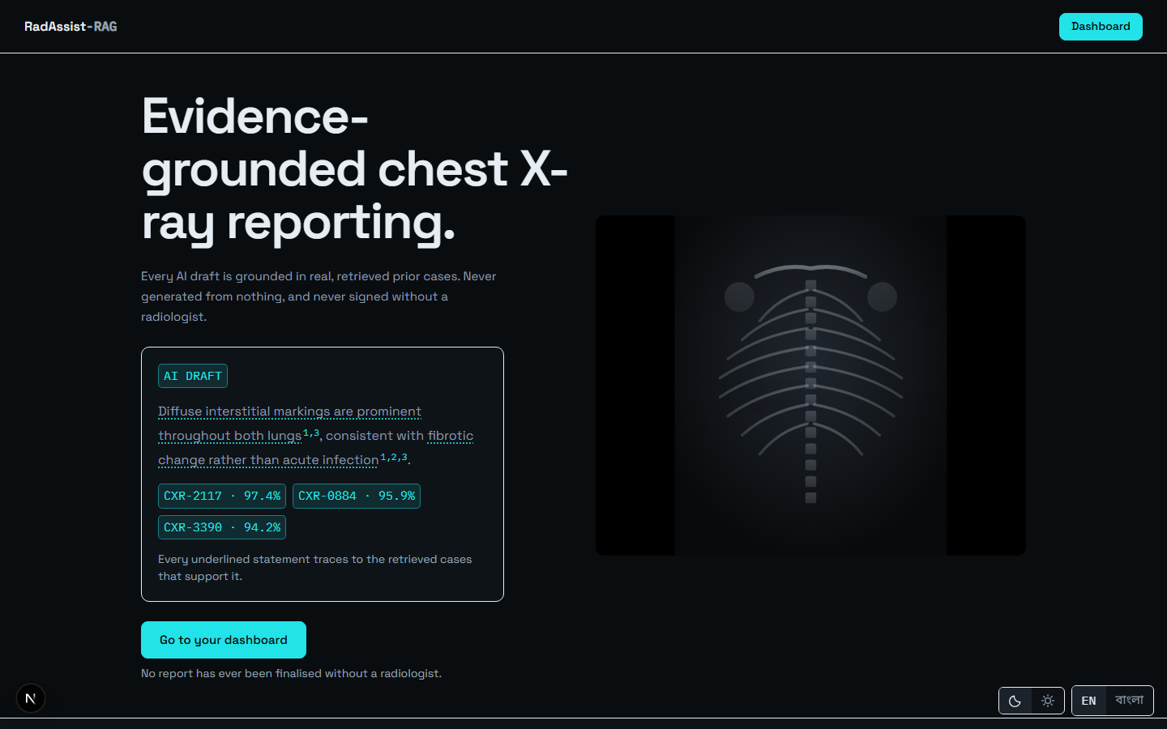
Figure 7.1: The public landing page — the first screen a new user meets.
Source: thesis final report/05_screenshots/01-landing-dark.png, captured 2026-09-23 at 1440×900 from the running system against a disposable copy of the development database.
From the landing page, choose Sign in or Register.
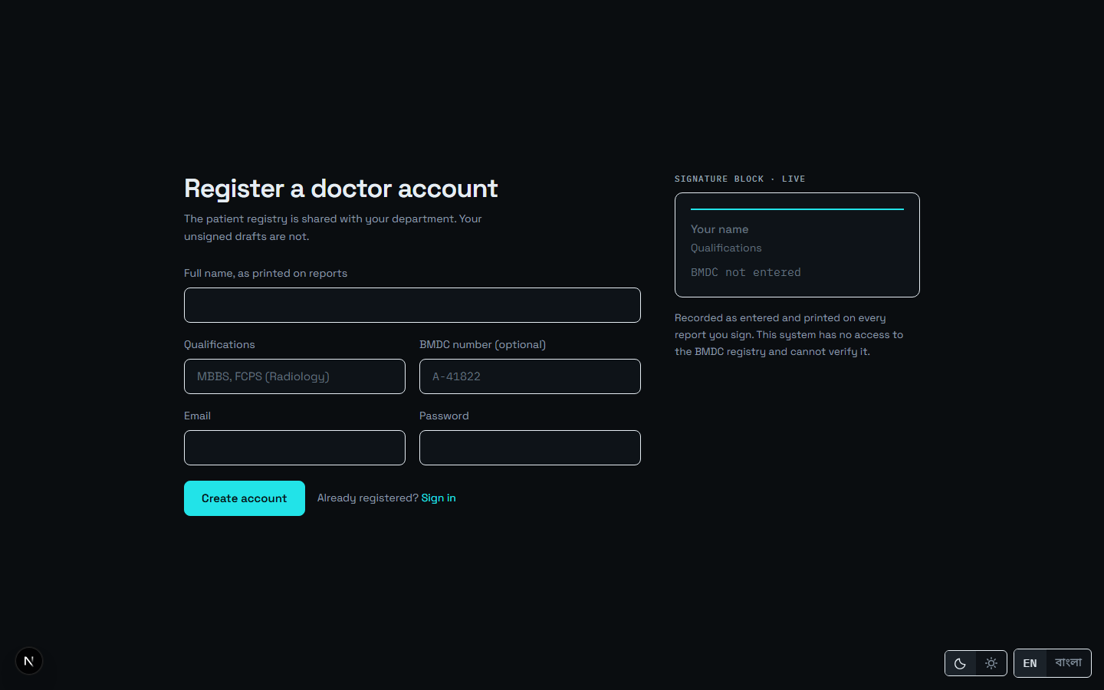
Figure 7.2: Doctor registration: full name, email, BMDC number and password.
Source: thesis final report/05_screenshots/02-registration-dark.png, captured 2026-09-23 at 1440×900 from the running system against a disposable copy of the development database.
Your BMDC number is recorded exactly as you type it and is never checked. The form says so itself: “This system has no access to the BMDC registry and cannot verify it.” The number is stored and printed on the report; it is not a verified credential, and nothing in the system treats it as one.
Passwords are stored as Argon2id hashes. There is no password reset facility — see §7.12.
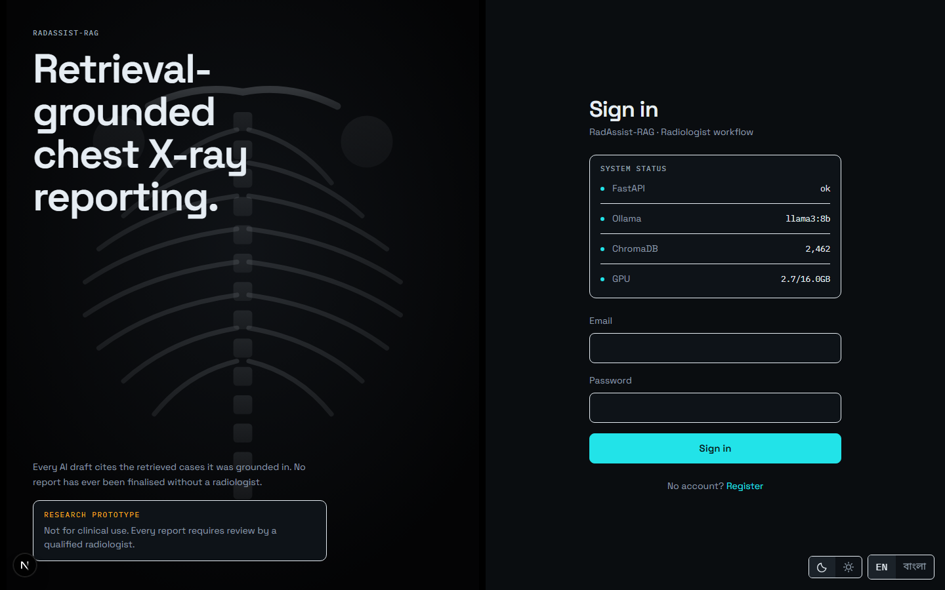
Figure 7.3: Sign in with email and password. A successful sign-in lands on the queue.
Source: thesis final report/05_screenshots/03-login-dark.png, captured 2026-09-23 at 1440×900 from the running system against a disposable copy of the development database.

7.3 The Queue — Your Worklist
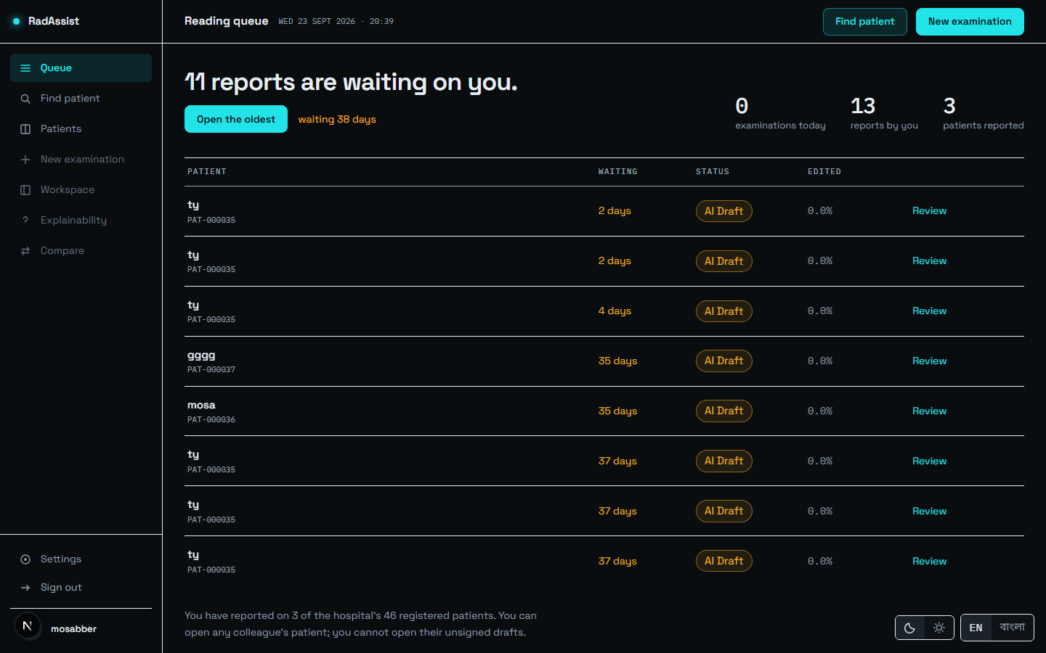
Figure 7.4: The queue: every report this doctor owns, newest first, each with its patient, date and status chip.
Source: thesis final report/05_screenshots/04-queue-dark.png, captured 2026-09-23 at 1440×900 from the running system against a disposable copy of the development database.
The queue is where signing in takes you. Each row carries a status chip — AI Draft, Doctor edited or Final — which is the report’s position in the authorship workflow rather than a quality indication. Clicking any row reopens that report.
The counts above the list are computed to agree with the list by construction: the examinations count joins to reports rather than to upload sessions, so a session abandoned before generation is not counted as an examination performed.

7.4 Finding or Creating a Patient
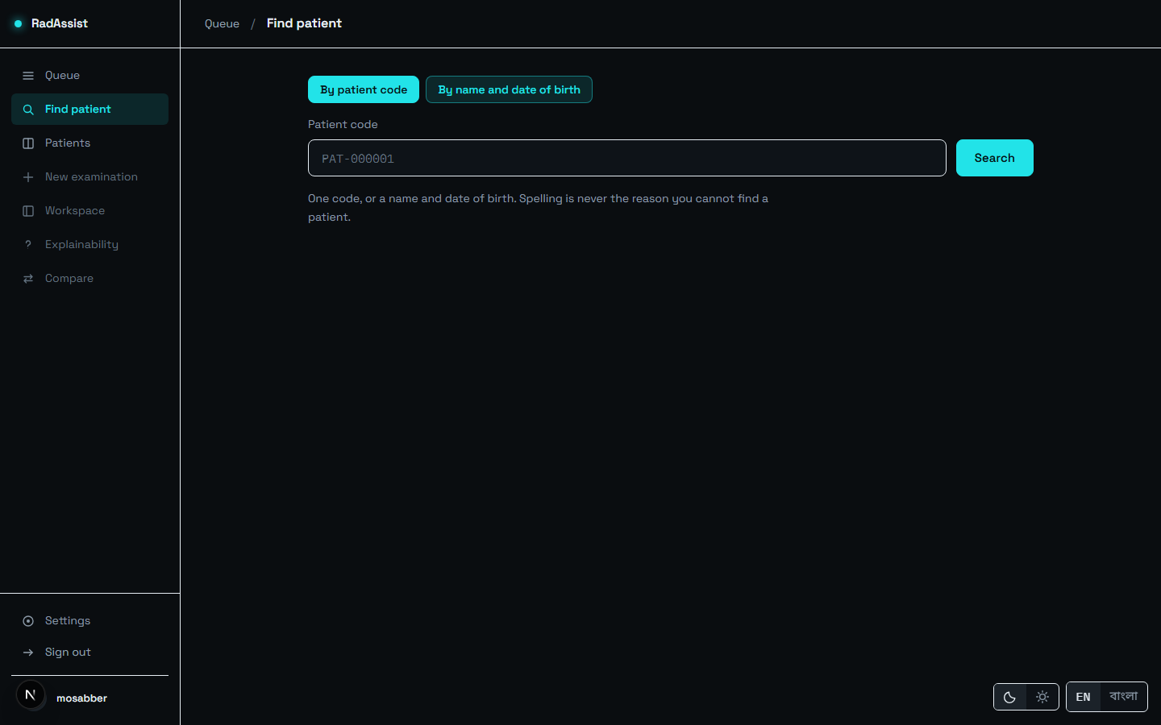
Figure 7.5: Find a patient by code or name before starting an examination.
Source: thesis final report/05_screenshots/05-find-patient-dark.png, captured 2026-09-23 at 1440×900 from the running system against a disposable copy of the development database.
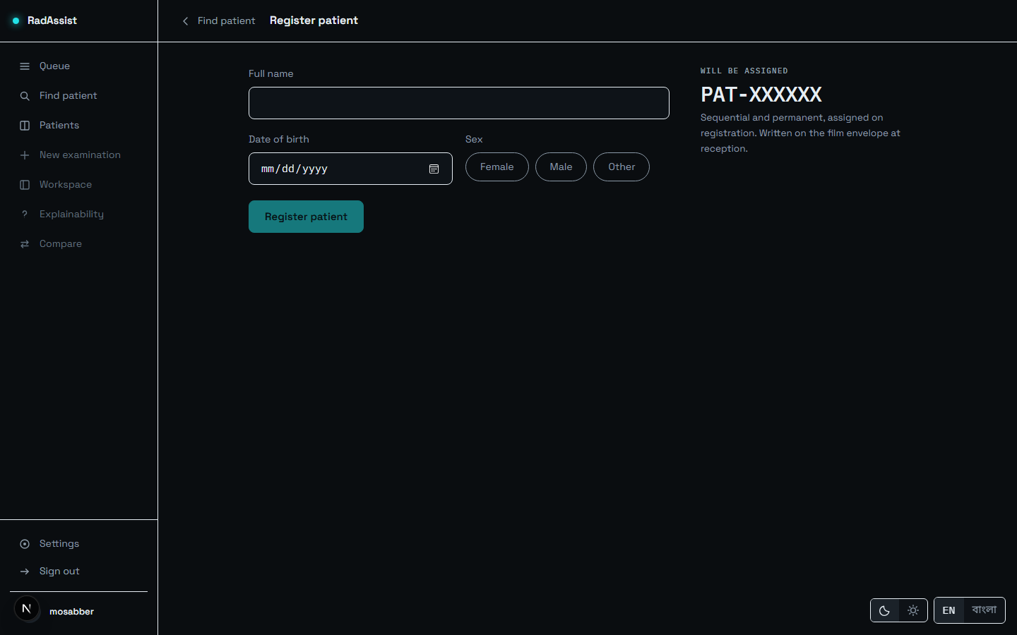
Figure 7.6: Registering a new patient: name, date of birth and gender. The system assigns the patient code.
Source: thesis final report/05_screenshots/07-register-patient-dark.png, captured 2026-09-23 at 1440×900 from the running system against a disposable copy of the development database.
Date of birth is bounded on both sides — in the input control and again in the backend — because an out-of-range year previously reached the date parser and produced an unhandled error rather than a field message.
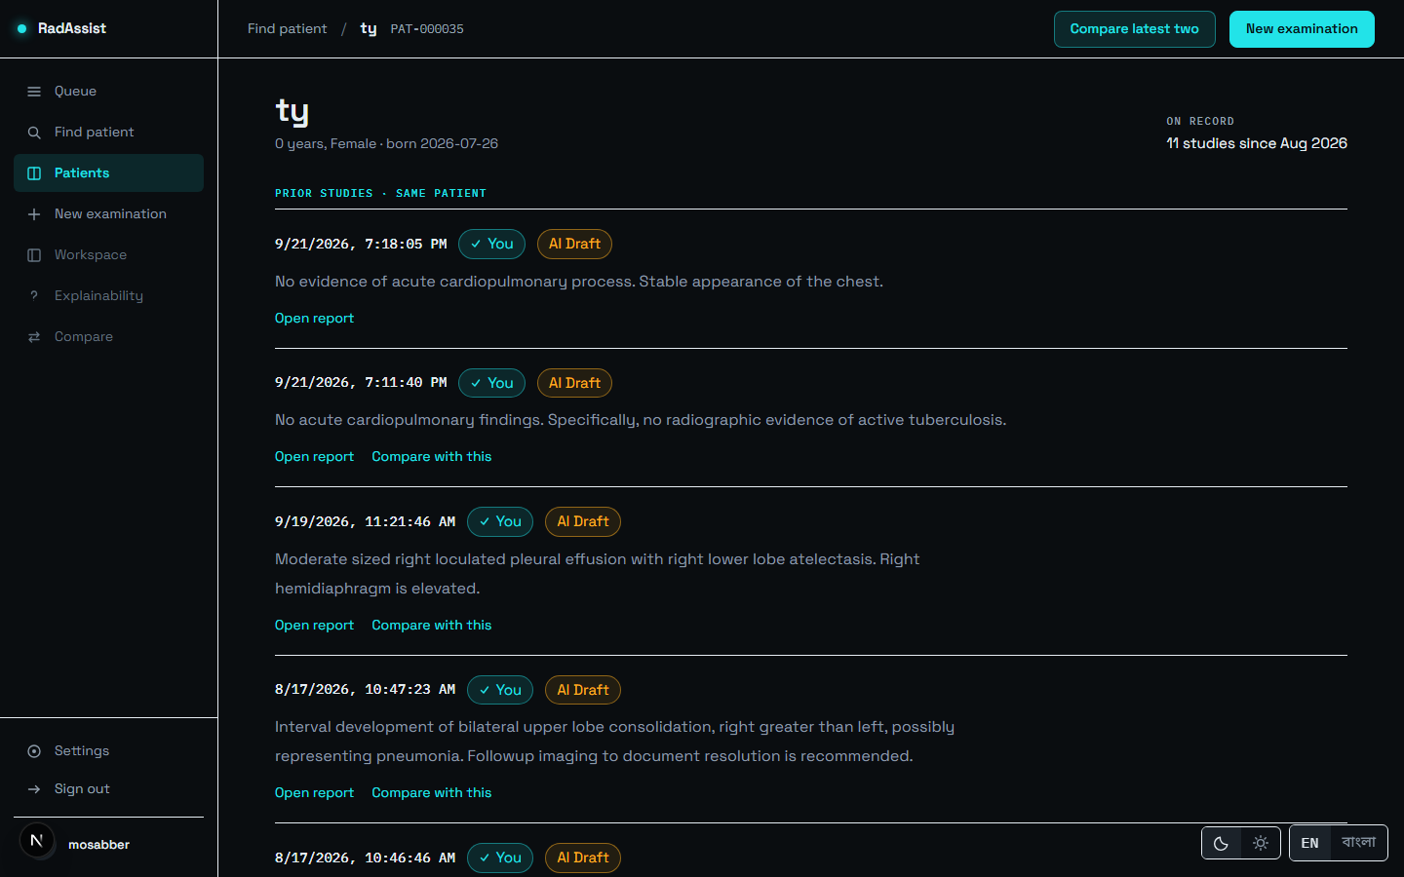
Figure 7.7: The patient profile: demographics and every prior study, in chronological order. This list is what makes comparison possible later.
Source: thesis final report/05_screenshots/08-patient-profile-dark.png, captured 2026-09-23 at 1440×900 from the running system against a disposable copy of the development database.
Patients are institutional, not owned: any authenticated doctor can find and open any patient. Ownership attaches to the work — the examinations and reports — not to the person.

7.5 New Examination — the Generate Step
This is step one of the three-step workspace: Generate → Report → Evidence.
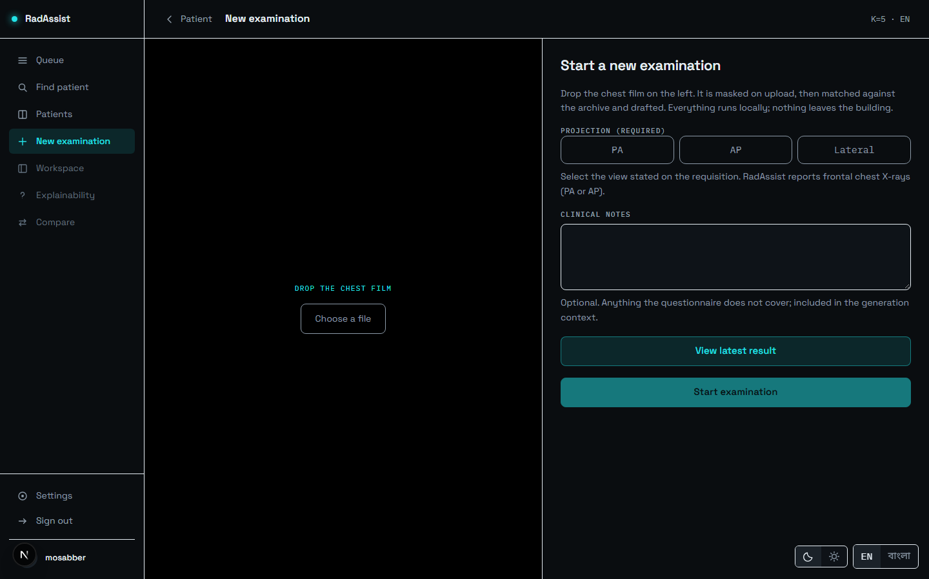
Figure 7.8: New examination: the film drop target before an image is chosen.
Source: thesis final report/05_screenshots/09-new-examination-dark.png, captured 2026-09-23 at 1440×900 from the running system against a disposable copy of the development database.
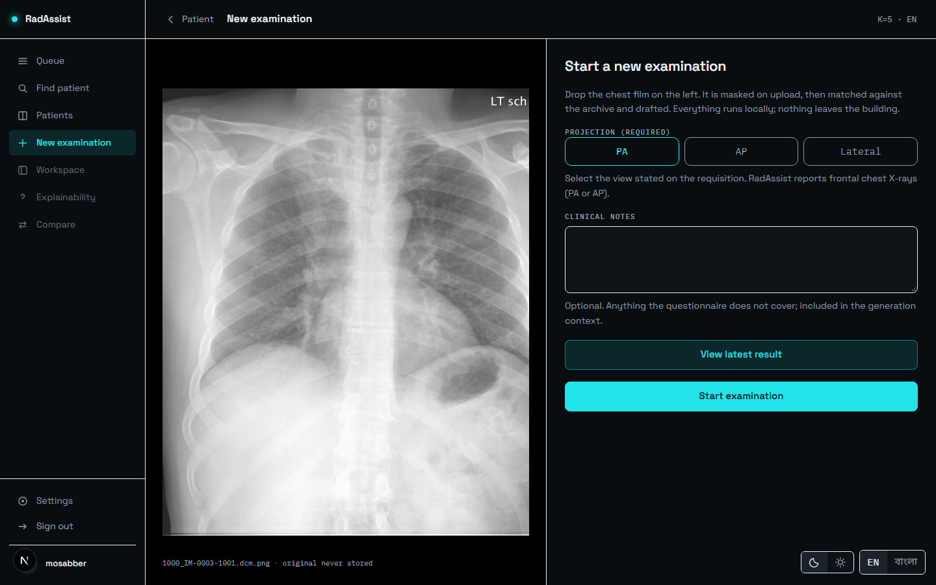
Figure 7.9: A film selected with the projection declared. Start examination stays disabled until a projection is picked.
Source: thesis final report/05_screenshots/10-upload-selected-dark.png, captured 2026-09-23 at 1440×900 from the running system against a disposable copy of the development database.
Declaring the projection is required, not optional: the control to begin stays disabled until PA, AP or Lateral is chosen. A lateral declaration is refused — the system reports frontal chest radiographs only — and it is refused before the image is masked, embedded or used to query anything.
Optional clinical notes may be typed here: “anything the questionnaire does not cover; included in the generation context.” A reveal slider shows the uploaded original beside the masked copy, drawn from a local browser object — the original is never uploaded or stored.
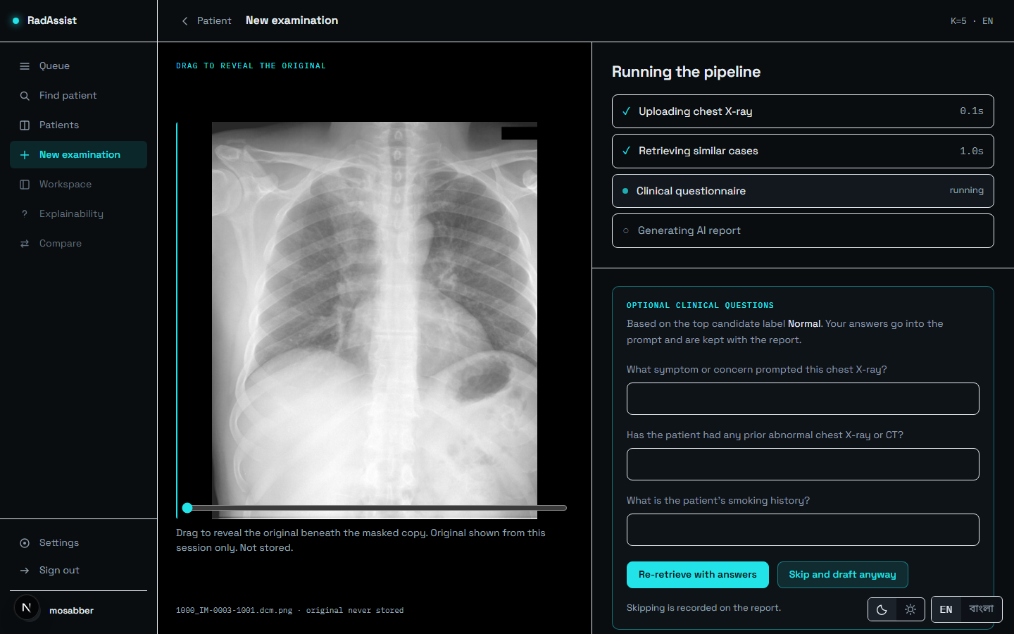
Figure 7.10: Generation in progress: four steps with live per-step timings — uploading, retrieving similar cases, clinical questionnaire, generating the report.
Source: thesis final report/05_screenshots/11-generate-in-progress-dark.png, captured 2026-09-23 at 1440×900 from the running system against a disposable copy of the development database.
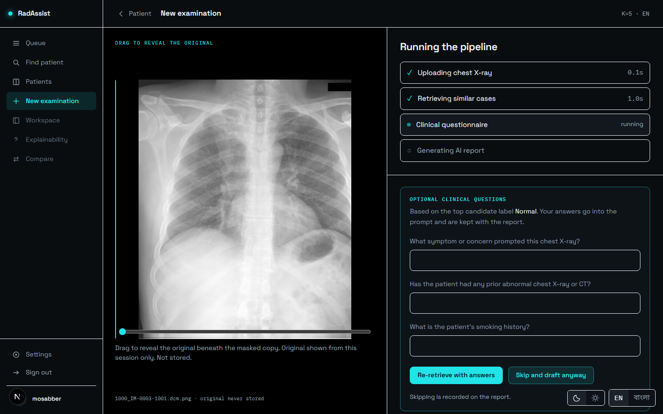
Figure 7.11: The clinical questionnaire, offered after retrieval. Its questions are conditioned on the retrieved findings. It can be skipped, and skipping can be made your default.
Source: thesis final report/05_screenshots/12-questionnaire-dark.png, captured 2026-09-23 at 1440×900 from the running system against a disposable copy of the development database.
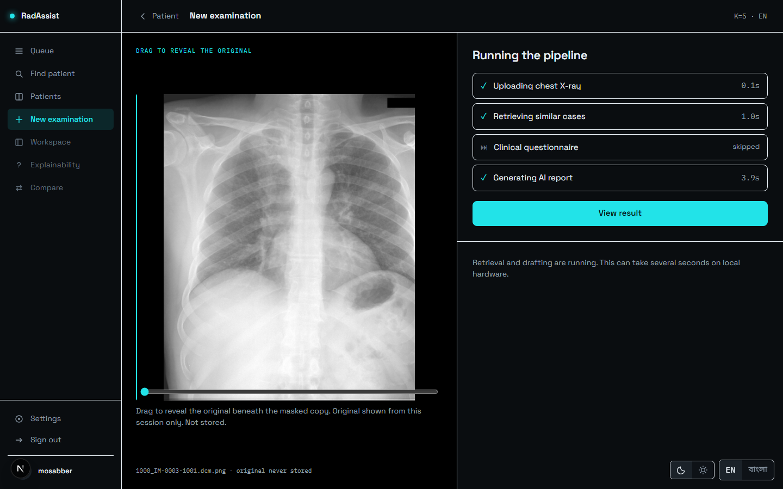
Figure 7.12: All four steps complete. In this captured run: upload 0.1 s, retrieval 1.0 s, questionnaire skipped, generation 3.9 s. This is one observation on one machine, not a benchmark — the measured distributions are in §6.9.
Source: thesis final report/05_screenshots/13-generate-complete-dark.png, captured 2026-09-23 at 1440×900 from the running system against a disposable copy of the development database.
The page does not navigate on its own. The per-step timings stay on screen until you press View result, so the pipeline’s behaviour is readable rather than appearing for a single frame.
What can go wrong at this step. A lateral film is rejected at admission. A film whose projection does not match what you declared is rejected after embedding. An image that is not a chest radiograph is refused by the modality gate. All three report on the retrieval step, and in every case both copies of the image are destroyed before the refusal returns.

7.6 The Report — Reviewing the Draft
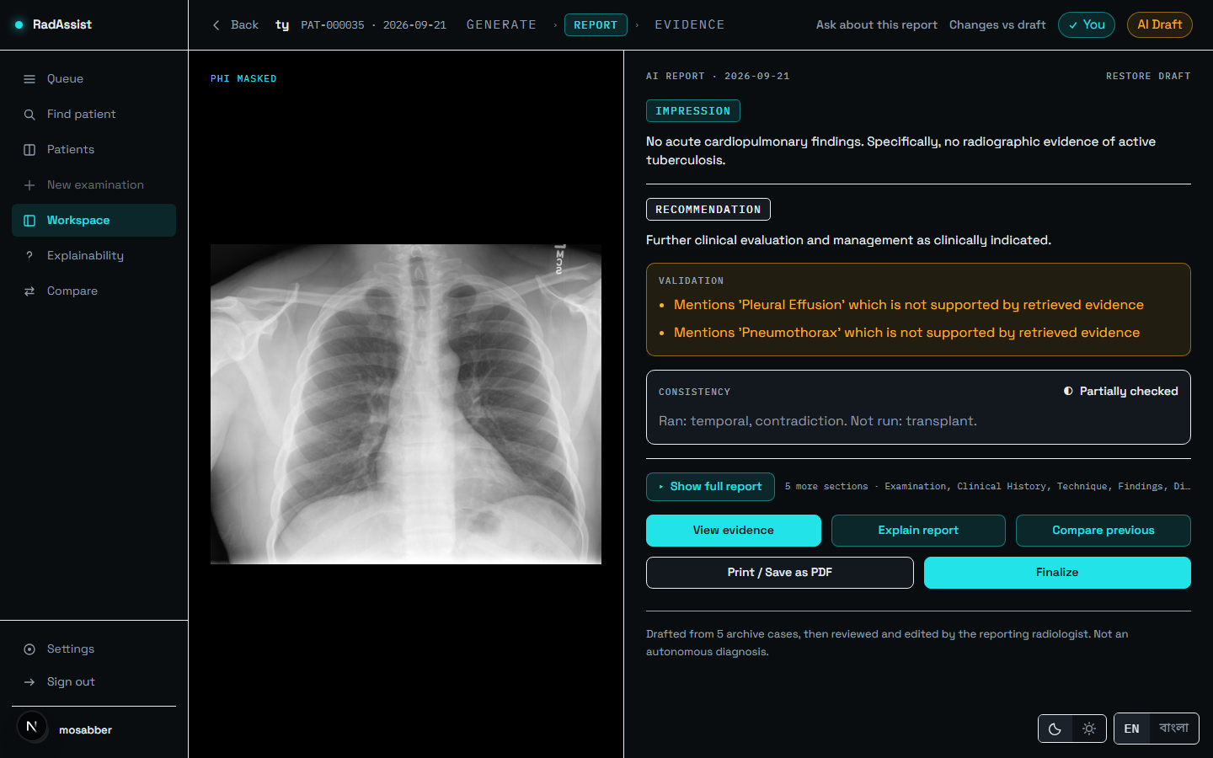
Figure 7.13: The report page. Summary first: impression and recommendation, the validation block and the consistency verdict are all visible without opening anything, with the masked film on the left.
Source: thesis final report/05_screenshots/14-result-partial-dark.png, captured 2026-09-23 at 1440×900 from the running system against a disposable copy of the development database.
Read the Impression and Recommendation first — the summary shows these two because they are the conclusions. The Validation box, where present, carries advisory warnings such as “Mentions ‘Pleural Effusion’ which is not supported by retrieved evidence.” The Consistency box carries one of three states you will actually see.

7.6.1 Reading the consistency verdict
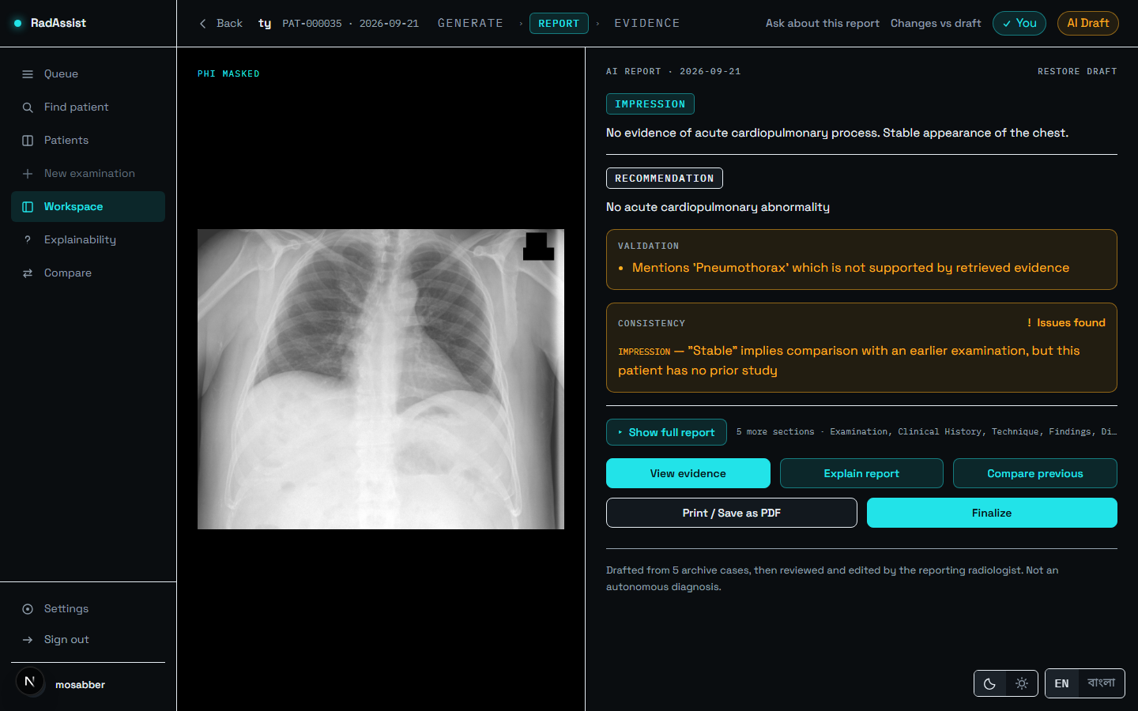
Figure 7.14: violations: a check found a problem — here a temporal-check violation on a report with no prior study. This is the actionable state.
Source: thesis final report/05_screenshots/15-result-violations-dark.png, captured 2026-09-23 at 1440×900 from the running system against a disposable copy of the development database.
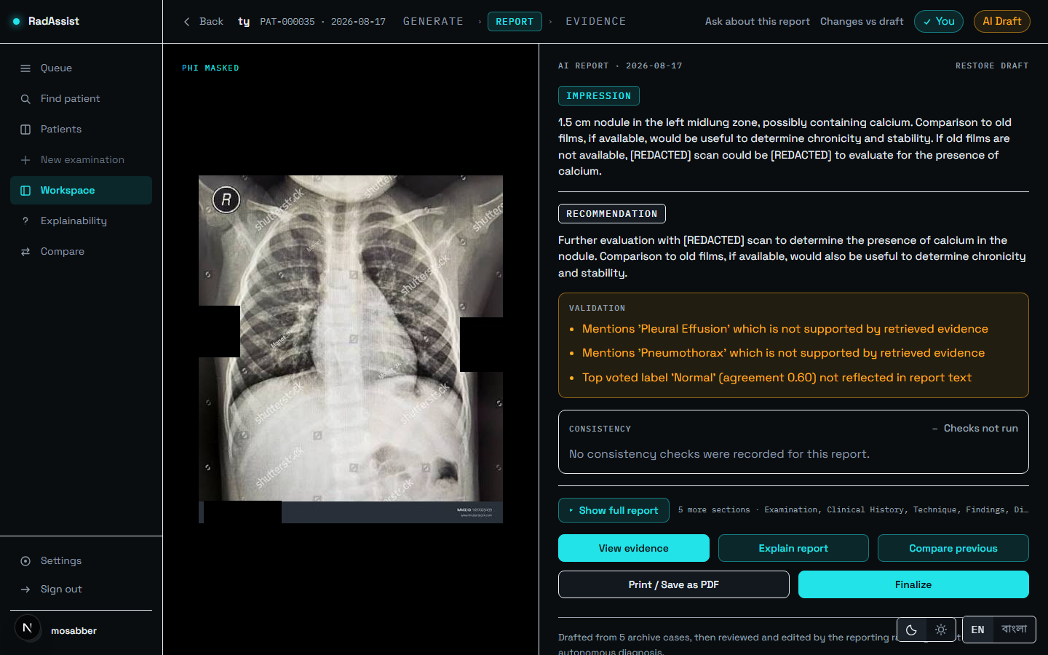
Figure 7.15: not_run: nothing was assessed. A pre-v1.2 report, shown with three validation warnings. This is not a pass.
Source: thesis final report/05_screenshots/16-result-warnings-dark.png, captured 2026-09-23 at 1440×900 from the running system against a disposable copy of the development database.
Table 7.2: The four consistency states and what each one licenses you to conclude.
Source: amendment_01_consistency_status.md §2; see §5.3.6.
State | What it means for you
Partially checked | Some applicable checks ran; at least one did not. The label names both halves: “Ran: temporal, contradiction. Not run: transplant.” This is not a pass. Every English report in this build reads this, because the transplant check has no calibrated threshold.
Violations | A check found a problem. Read the report with that specific concern in mind. Nothing is corrected automatically — the violation is recorded and acted on by nothing.
Checks not run | Nothing was assessed — a Bengali report, or a report generated before the checks existed. Not a pass.
Clean | The only genuine pass. Unreachable in this build, and you will not see it, because one of the three checks cannot yet report a result.

7.6.2 Editing and finalizing
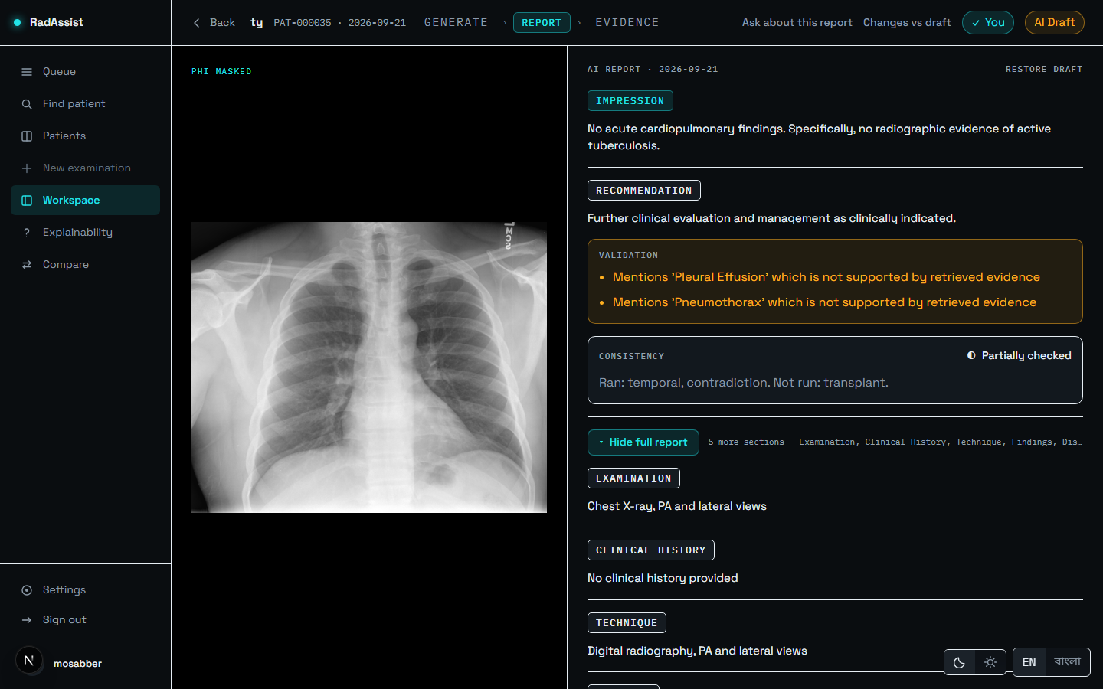
Figure 7.16: Show full report: all seven fields — Examination, Clinical History, Technique, Findings, Impression, Recommendation, Disclaimer.
Source: thesis final report/05_screenshots/18-full-report-expanded-dark.png, captured 2026-09-23 at 1440×900 from the running system against a disposable copy of the development database.
Five of the seven fields are editable directly; Examination and Disclaimer are set by the system. Editing a field moves the status chip to Doctor edited, and Changes vs draft shows a word-level comparison against the original AI draft. Any editable section can be regenerated individually, producing a candidate you accept or discard.
Press Finalize when the report is yours. Finalizing is a one-way door: after it, edits are refused, and deletion is refused too, because a signed report is an audit record.
A validation warning always describes the AI draft, never your edited text. Warnings are computed once, at generation, and are not recomputed when you edit — so a warning on a finalized report may describe text that no longer exists.

7.7 Evidence — What the Draft Was Built From
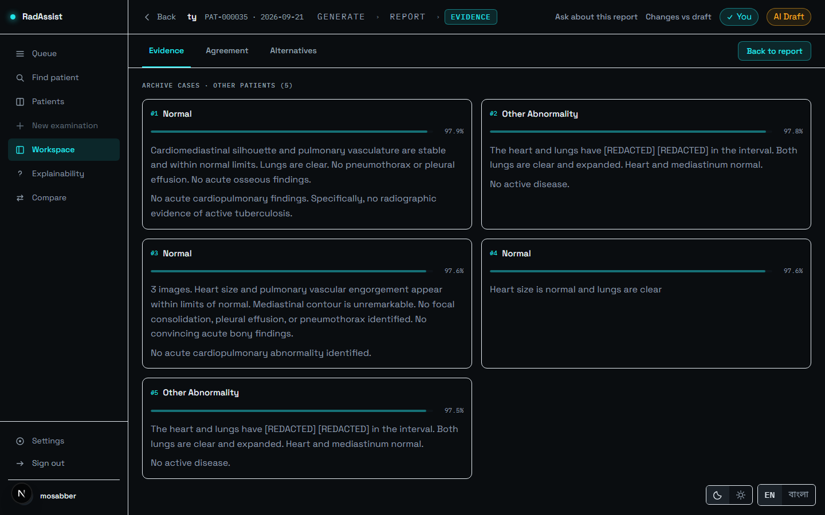
Figure 7.17: The Evidence tab: the five retrieved neighbour cases and their similarities.
Source: thesis final report/05_screenshots/19-evidence-tab-evidence-dark.png, captured 2026-09-23 at 1440×900 from the running system against a disposable copy of the development database.
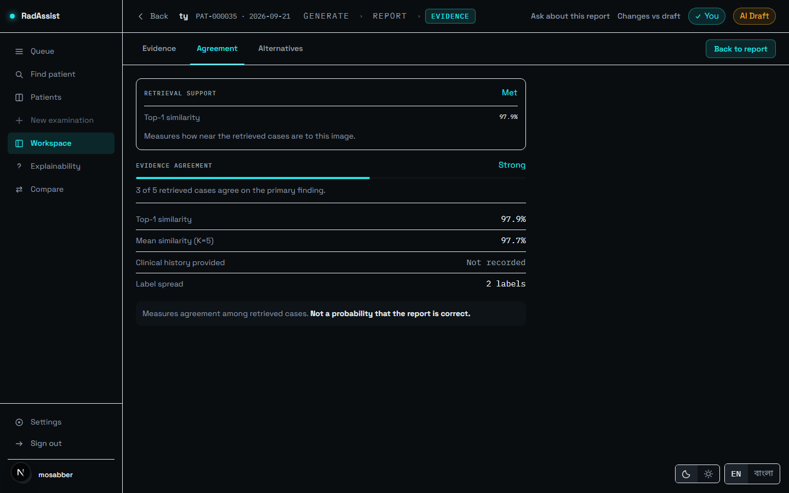
Figure 7.18: The Agreement tab: retrieval support, top-1 and mean similarity, and how many retrieved cases agree on the primary finding.
Source: thesis final report/05_screenshots/20-evidence-tab-agreement-dark.png, captured 2026-09-23 at 1440×900 from the running system against a disposable copy of the development database.
The agreement figure is not a confidence score, and the panel says so: “Measures agreement among retrieved cases. Not a probability that the report is correct.” Five cases can agree with one another and all be unlike the patient in front of you.
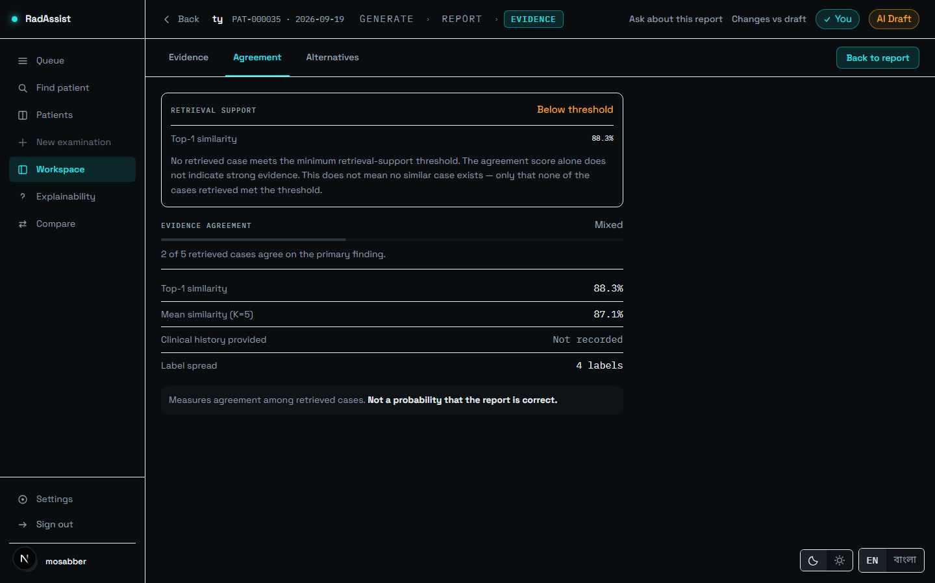
Figure 7.19: Retrieval support reading Below threshold, at a top-1 similarity of 88.3%. Treat the draft with extra care when you see this.
Source: thesis final report/05_screenshots/17-evidence-below-floor-dark.png, captured 2026-09-23 at 1440×900 from the running system against a disposable copy of the development database.
The notice states its own limit precisely: “No retrieved case meets the minimum retrieval-support threshold… This does not mean no similar case exists — only that none of the cases retrieved met the threshold.”
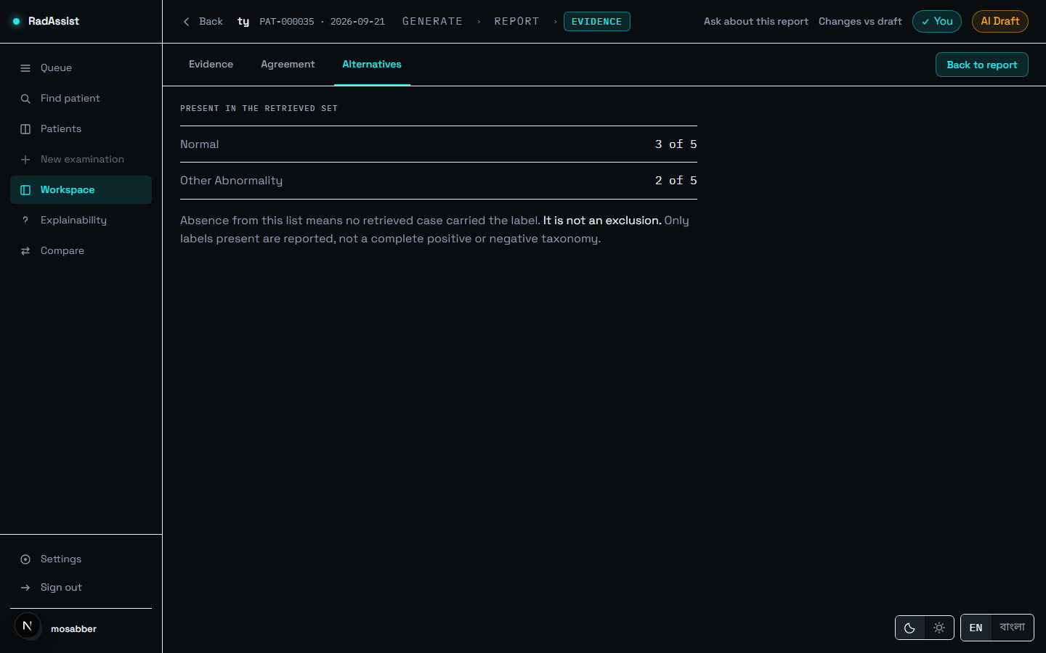
Figure 7.20: The Alternatives tab: the labels that did not win the vote.
Source: thesis final report/05_screenshots/21-evidence-tab-alternatives-dark.png, captured 2026-09-23 at 1440×900 from the running system against a disposable copy of the development database.
Moving between Report and Evidence makes no new request — both pages read the same fetched report, so navigation between them is immediate.

7.8 Explainability — Asking About the Draft
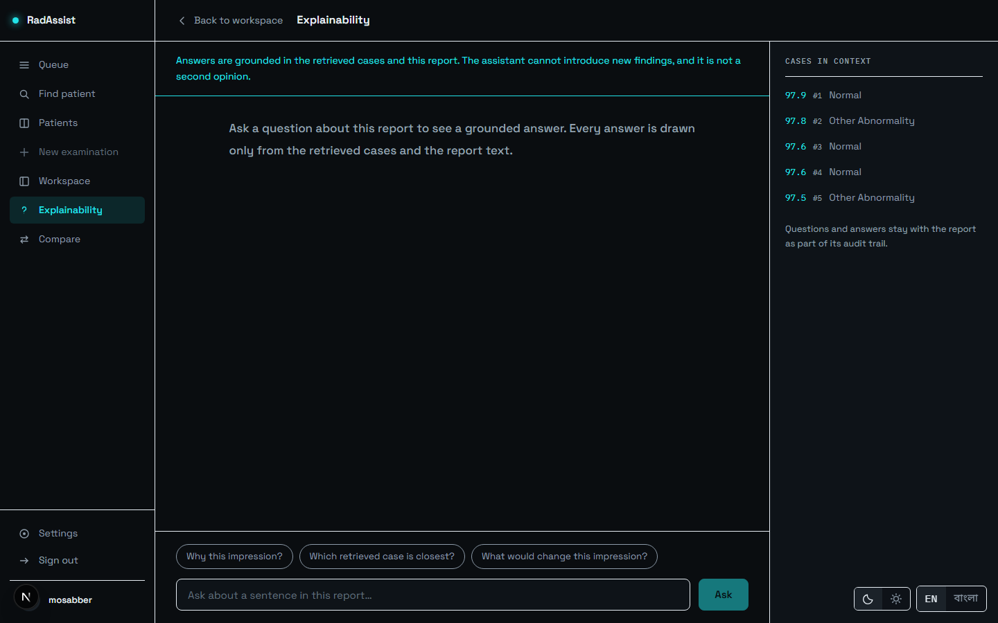
Figure 7.21: The explainability screen: suggested questions, and the cases in context with their similarities.
Source: thesis final report/05_screenshots/22-explainability-idle-dark.png, captured 2026-09-23 at 1440×900 from the running system against a disposable copy of the development database.
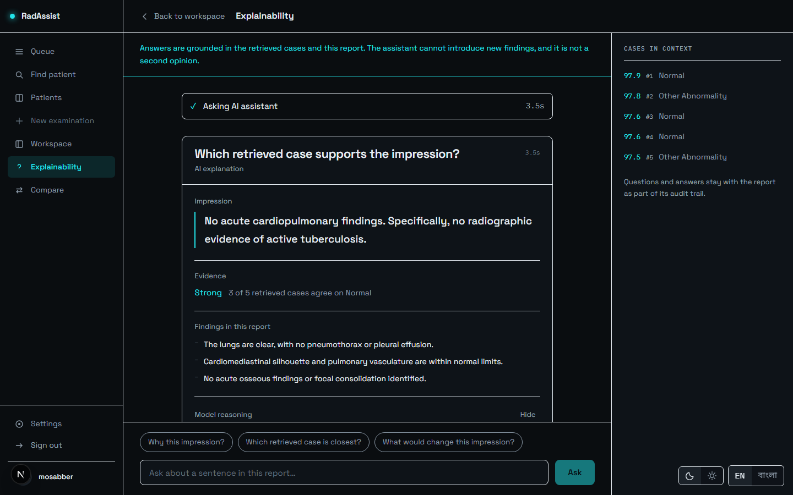
Figure 7.22: An answered question: the impression, the evidence strength, and the findings the answer rests on.
Source: thesis final report/05_screenshots/23-explainability-answered-dark.png, captured 2026-09-23 at 1440×900 from the running system against a disposable copy of the development database.
Pick a suggested question or type your own. Answers are grounded in the same evidence block the report used: “The assistant cannot introduce new findings, and it is not a second opinion.” Questions and answers stay with the report as part of its audit trail.
One limitation applies here and is stated rather than implied: the explainability prompt was changed by the v1.2 work and its output has never been evaluated by any endpoint in this project.

7.9 Compare — This Study Against a Prior
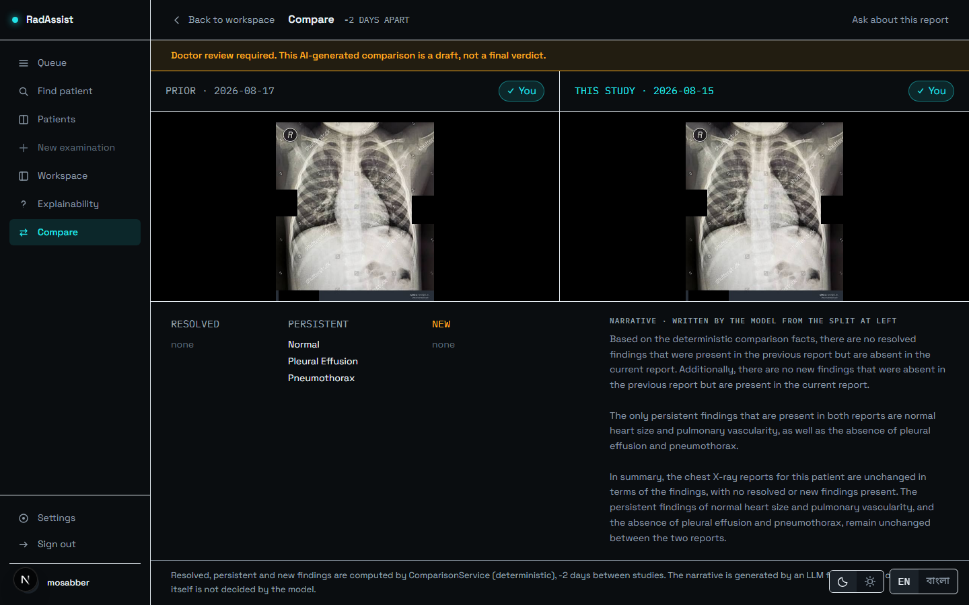
Figure 7.23: Comparison: both films side by side with their impressions, and the resolved / persistent / new split.
Source: thesis final report/05_screenshots/24-compare-dark.png, captured 2026-09-23 at 1440×900 from the running system against a disposable copy of the development database.
Comparison requires a prior report for the same patient, and any prior study may be chosen — not only the most recent. The three-column split of Resolved / Persistent / New is computed deterministically, and the narrative beneath it is written by the language model from that split only. The provenance line at the foot states which part is which: the change itself is not decided by the model.
A known defect is visible in this screenshot. The interval reads “-2 DAYS APART” — a negative value, because the prior study in the seeded capture data is dated after the current one. The system neither reorders nor rejects that ordering: the comparison is computed correctly but the guard against a reversed interval is missing.

7.10 Printing and Saving as PDF
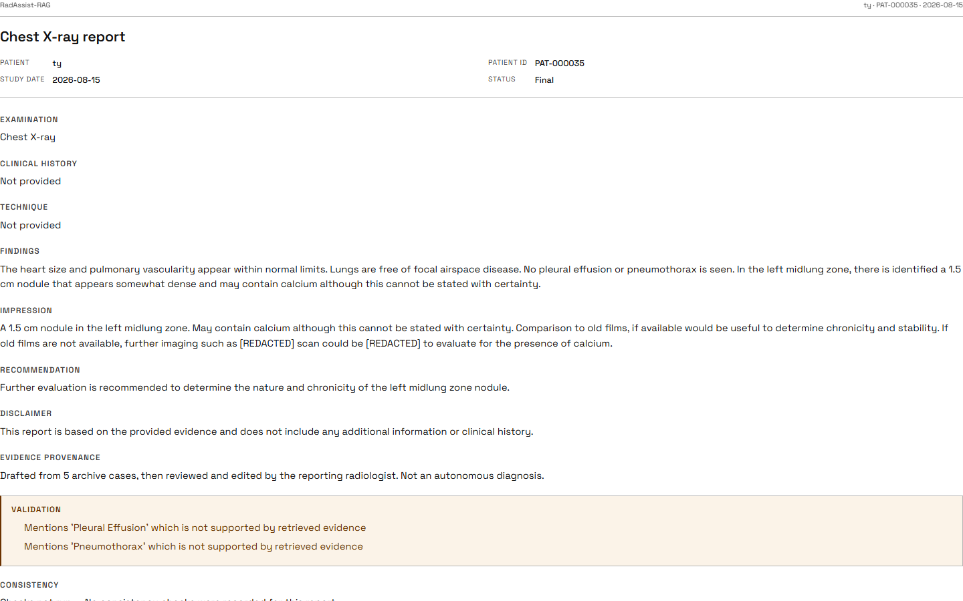
Figure 7.24: Print / Save as PDF: a one-page document with the header, all seven fields, and the validation and consistency blocks.
Source: thesis final report/05_screenshots/25-print-preview-dark.png, captured 2026-09-23 at 1440×900 from the running system against a disposable copy of the development database.
Press Print / Save as PDF, then choose Save as PDF in your browser. The printed document carries all seven fields regardless of what was open on screen, because it is built independently of the interface state rather than by re-styling the screen.
This is browser print. There is no server-side PDF generator — the file is produced by your browser, so its pagination and fonts are your browser’s. The control is labelled accordingly.
The validation warnings and the consistency verdict always print, in every state. The signature block prints only on a finalized report: a draft is not a signed document, and a name printed under one would claim otherwise on a page that outlives the screen.

7.11 Settings, Language and Theme
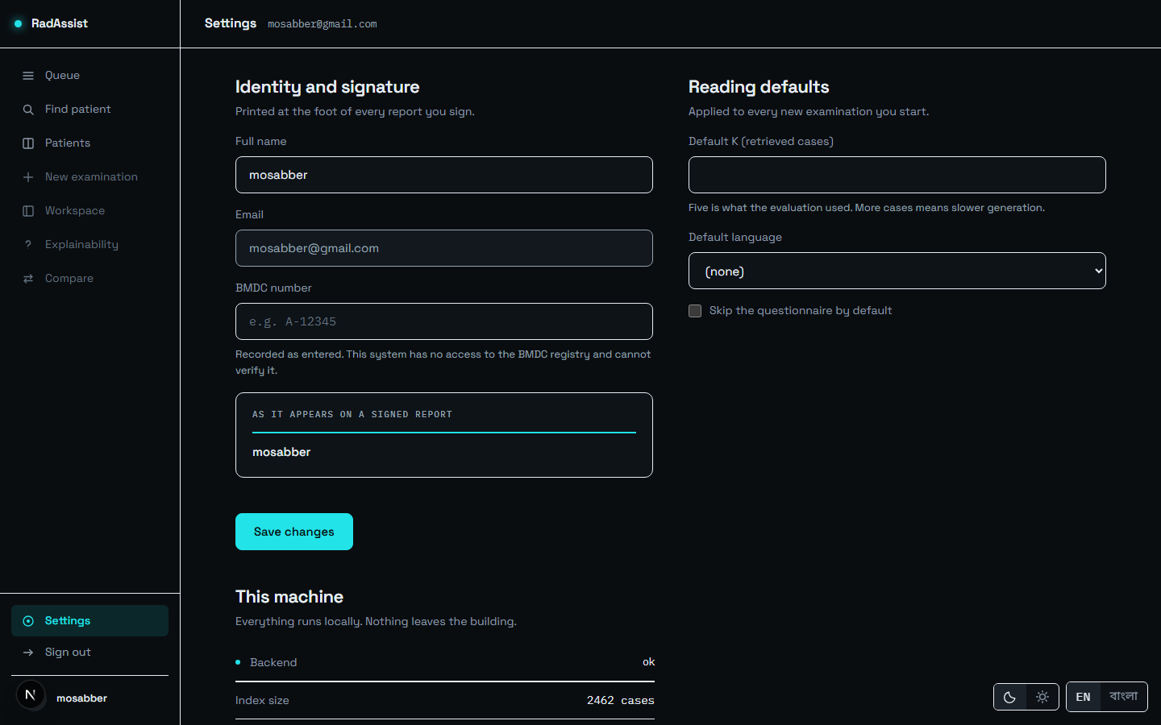
Figure 7.25: Settings: profile fields and workspace defaults. Settings is the profile screen — there is no separate profile route.
Source: thesis final report/05_screenshots/26-settings-profile-dark.png, captured 2026-09-23 at 1440×900 from the running system against a disposable copy of the development database.
Settings holds your name and BMDC number together with workspace defaults: how many neighbour cases to retrieve, your default language, and whether to skip the questionnaire. These become the defaults for every new examination — and they are genuinely honoured, which was not always true: an earlier build persisted preferences that nothing read, and two preferences whose promised behaviour did not exist were removed from the screen rather than left as inert controls.
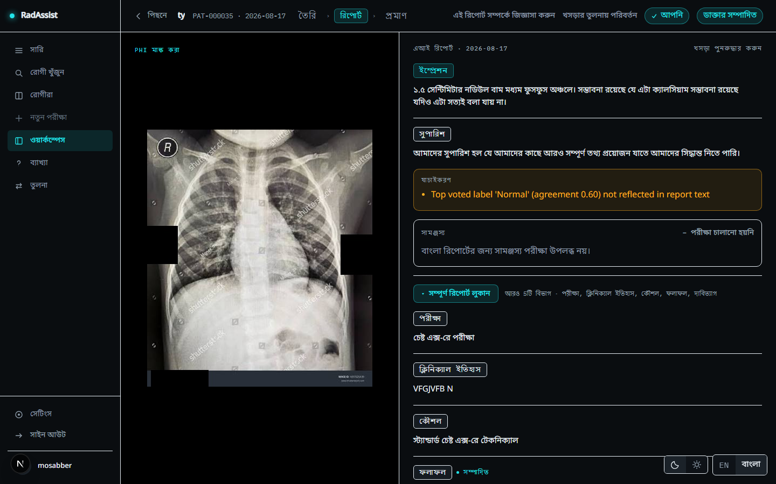
Figure 7.26: A Bengali report: the interface and the report body are both in Bengali, and the consistency block reads “checks not run” with the reason given in Bengali.
Source: thesis final report/05_screenshots/27-report-bengali-dark.png, captured 2026-09-23 at 1440×900 from the running system against a disposable copy of the development database.
The EN / বাংলা toggle is on every screen. Switching it changes the whole interface, and new reports are drafted in the selected language — generated directly in Bengali, not translated from English.
A Bengali report always reads “consistency checks not run”. All three checks are English-only, and the system is deliberate about showing this rather than showing nothing: a Bengali report showing a green tick — or showing nothing at all, which a clinician reads as “nothing wrong” — would convert an acknowledged coverage gap into an affirmative false assurance, which is worse than the gap itself.
A known gap is visible in Figure 7.26: the validation warning text is still in English on an otherwise fully Bengali screen, because those strings are composed by the backend rather than by the interface.
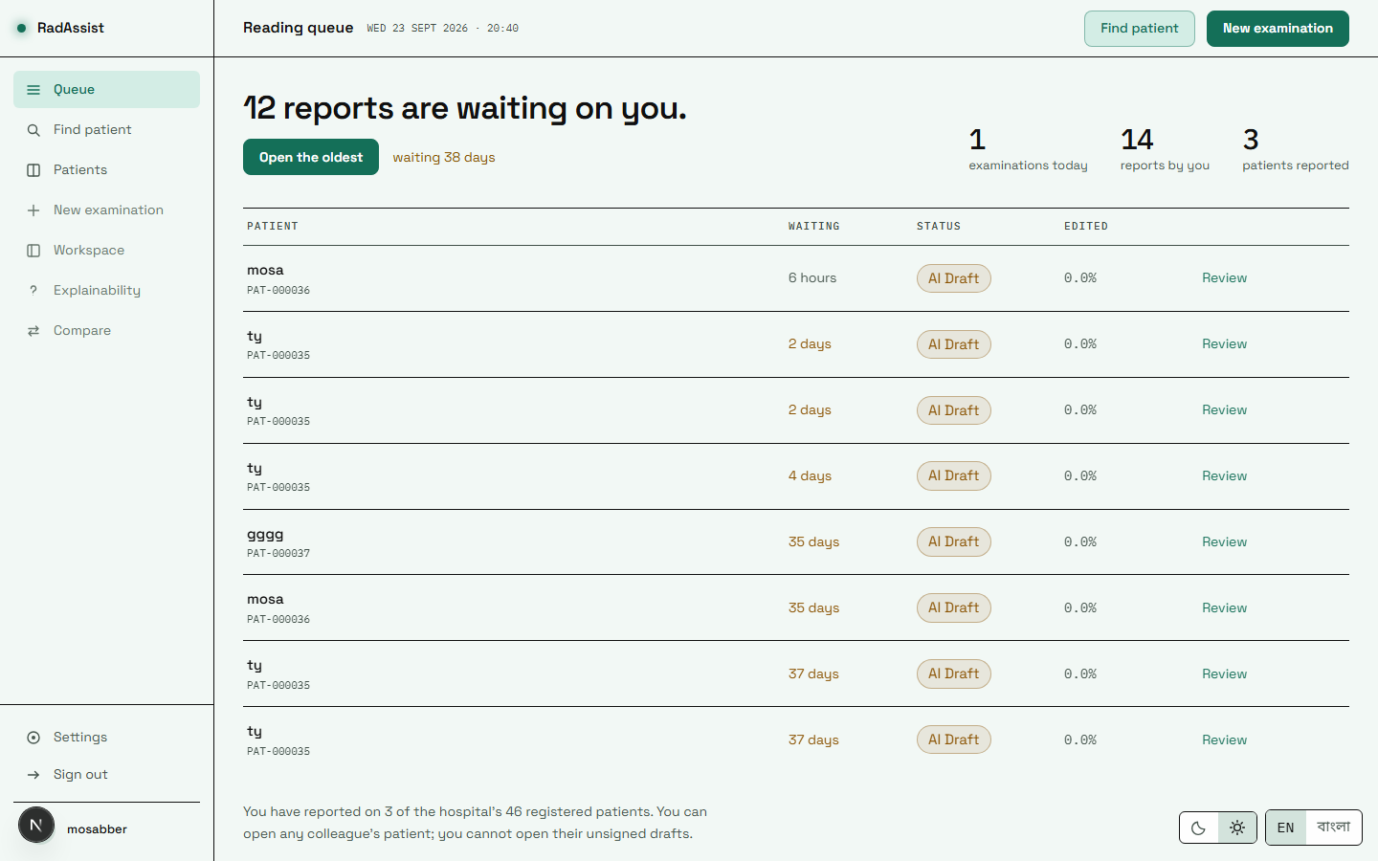
Figure 7.27: The queue in the light theme. Dark is the product’s native theme; light is a separately derived palette, not an inversion.
Source: thesis final report/05_screenshots/29-queue-light.png, captured 2026-09-23 at 1440×900 from the running system against a disposable copy of the development database.
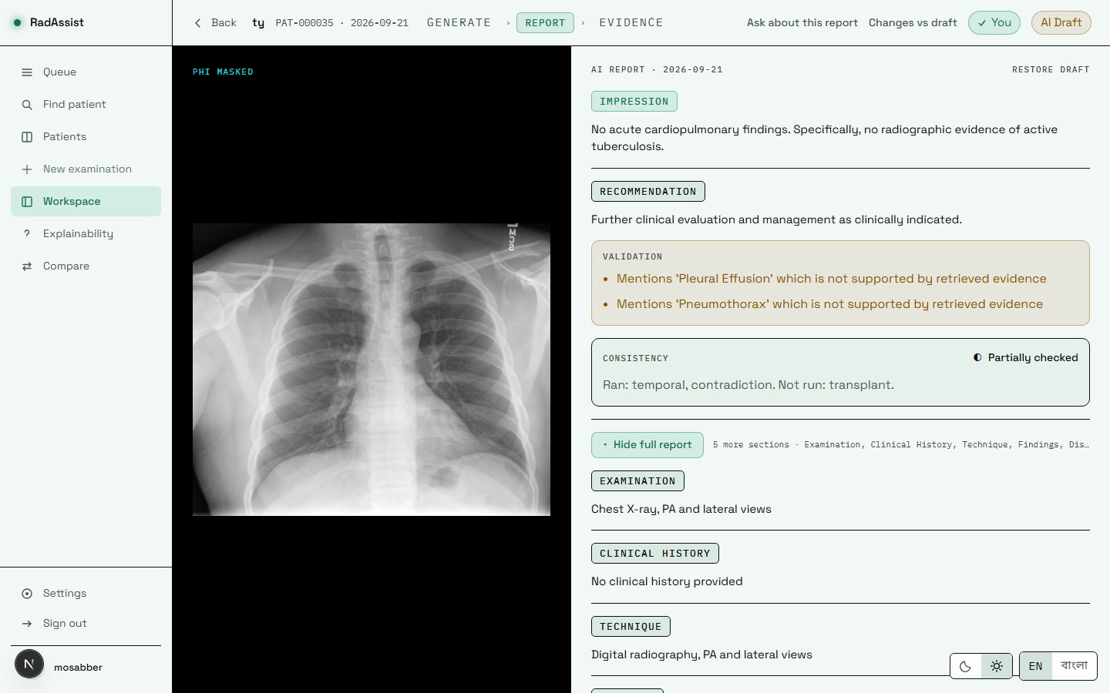
Figure 7.28: The report page in the light theme. Every colour pair was measured for contrast over its real backdrop in both themes.
Source: thesis final report/05_screenshots/31-result-partial-light.png, captured 2026-09-23 at 1440×900 from the running system against a disposable copy of the development database.
The moon/sun toggle sits beside the language toggle on every screen. The film panel stays black in both themes, because a radiograph is read against black and that is a clinical condition rather than a decorative choice.

7.12 What This Manual Must Not Promise
These are asked about often and do not exist in this build. They are listed here so the manual cannot be read as implying them.
Table 7.3: Capabilities the system does not have, and why.
Source: 07_manual/user_manual_outline.md §13; 01_facts/feature_catalogue.md §7.
Not available | Why
BMDC verification | No registry access. The number is stored exactly as typed and is never checked against anything.
An administrator role or screen | No role exists in the database. Access control is ownership only.
Server-side PDF export | Printing is the browser’s. No export endpoint and no PDF library exist.
Automatic correction of a consistency violation | Not built. Violations are recorded only — 17 of 477 in the evaluation run were acted on by nothing.
A “clean” consistency verdict | Unreachable until the transplant check’s threshold is calibrated.
Any Bengali quality guarantee | Never measured. No Bengali output has ever been evaluated in this project.
Password reset / forgot password | No reset-token storage and no mail transport. Self-registration performs no email verification either.
MRI, CT or lateral views | Frontal chest radiographs only, enforced at admission.
A diagnosis | The system is decision support. No output is a diagnosis, and no radiologist has validated any output it has produced.
This chapter has covered installation and every real screen of the delivered system, together with the capabilities it deliberately does not have. Chapter 8 concludes the report.

